Exploration 3A: Wait Times at Beef n’ Buns

For this exploration we will look at the waiting times collected by our observational data forms at Beef n' Buns. Assume that the following data (C03 Waittime.xls) represents the number of seconds the customer waited to receive his/her food at Beef n' Buns. Also included is a column of data showing a sample of service times from a competitor.

1. By hand, calculate the average wait time for a typical customer.
2. How many customers waited less than the average? How many waited more?
3. By hand, compute the deviations from the mean in a new column to the right of WaitTime.
4. What was the largest deviation from the mean?
5. What is the Total Deviation (or sum of the deviations) for this set of data?
6. Manually compute the Squared Deviation in a new column to the right.
7. Manually compute the Sum of the Squared Deviations (SSD) for this set of data.
8. Use your previous calculations to compute the Standard Deviation as follows:

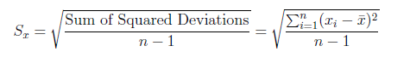

1. Now use built-in spreadsheet functions to compute the standard deviation.
2. Use your software to compute the mean and standard deviation for your competitor.
3. For which of the two fast food restaurants is the mean a better model for customer wait times? Why?