Exploration 7B: Adding Trendlines

Part I. Using data file C02 Homes.xls [.rda], answer each question below.

1. Create a scatterplot of SIZE and PRICE, as you did in the earlier exploration in this chapter. Add a trendline to it. Sketch the trendline here.

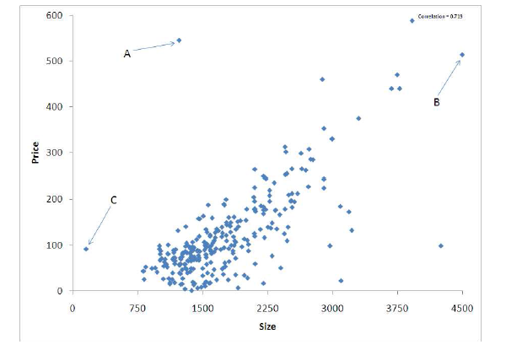

Figure 7.14: Scatterplot showing home price versus size.

1. Visually, how well does the trendline fit the data? Are there any points that seem to have undue influence on the trend or not follow the trend well?
2. What is the correlation coefficient (r) for this relationship? How does this compare with the visual evidence you considered?
3. Estimate the equation of the trendline for the relationship between the SIZE and PRICE of a home?

Part II. Create a new scatterplot between PRICE and TAXES. Be sure to do the following:

* Modify the font size
* Add units to both axis labels
* State the trendline equation in terms of the Model Variables
* Add a trendline

1. Visually, how well does the trendline fit the data? Are there any points that seem to have undue influence on the trend or not follow the trend well?
2. What is the correlation coefficient (r) for this relationship? How does this compare with the visual evidence you considered?
3. Estimate the equation of the trendline for the relationship between the PRICE and TAXES of a home?