Exploration 11B: Shifting and Scaling the Basic Models

Download and open the file C11 Exploration3.xls. When you open this file, you may be asked whether to enable the macros in the file or not. Click “Enable Macros” in order to make the file function properly. (This is part of the security of the computer; many viruses and computer worms are hidden in macros.) When you get the file open, you should see a screen like the one shown below:

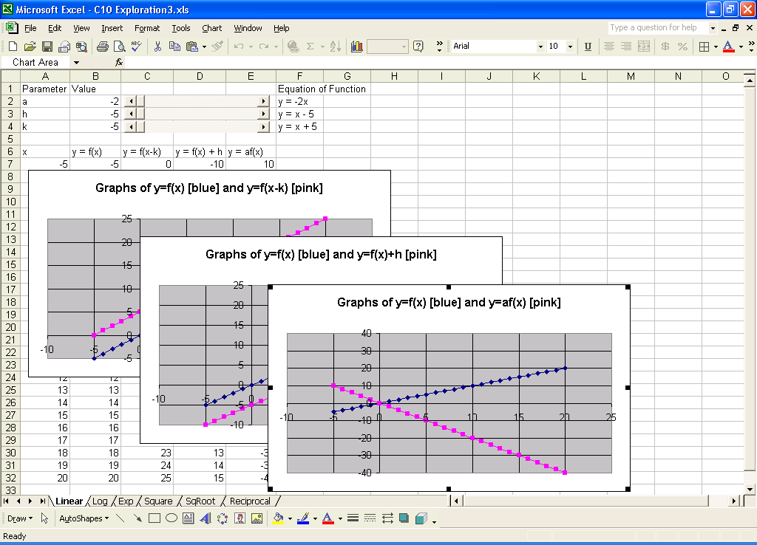

There are six worksheets in the workbook – one for each of the basic functions we have been discussing. On each worksheet there are three slider bars and three graphs. Each graph shows the graph of the basic function itself (in blue) and one other graph (in pink). As you change the slider values, make note of how the graph of the pink function changes and how the different equations shown next to the slider bars change. To see some of the graphs, you may need to right click on them and select “Bring to Front” since Excel layers its graphs on top of each other in order to save “screen real estate”.

After you have explored the various graphs and their shifts and scales, try to write down some general rules about these shifts and scales. Then, try to write down the most general form for each of the basic functions that you can, using parameters to represent the different features.

|  |  |  |
| --- | --- | --- |
| Linear Function, $f\left(x\right)=x$ | | |
| Modification | Sketch | Description |
|  |  |  |
|  |  |  |
|  |  |  |

|  |  |  |
| --- | --- | --- |
| Linear Function, $f\left(x\right)=ln⁡(x)$ | | |
| Modification | Sketch | Description |
|  |  |  |
|  |  |  |
|  |  |  |

|  |  |  |
| --- | --- | --- |
| Linear Function, | | |
| Modification | Sketch | Description |
|  |  |  |
|  |  |  |
|  |  |  |

|  |  |  |
| --- | --- | --- |
| Linear Function, | | |
| Modification | Sketch | Description |
|  |  |  |
|  |  |  |
|  |  |  |

|  |  |  |
| --- | --- | --- |
| Linear Function, | | |
| Modification | Sketch | Description |
|  |  |  |
|  |  |  |
|  |  |  |

|  |  |  |
| --- | --- | --- |
| Linear Function, | | |
| Modification | Sketch | Description |
|  |  |  |
|  |  |  |
|  |  |  |